**ST. MARCELINO ACADEMY-MATUGGA**

**END OF AUGUST HOME STUDY ASSESSMENT**

**SUBJECT: LITERACY B (SST)**

**CLASS: PRIMARY ONE**

**NAME: …………………………………………………..……... STREAM: …………**

**LITERACY B**

**1. Fill in correctly.**

cle___ner c ­­__ __ k head___eacher pup___ls

**2. Circle three wild animals.**

pig rat, dog, rabbit, snake, fish, cat

**3. Match correctly.**

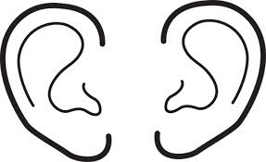

**for smelling**

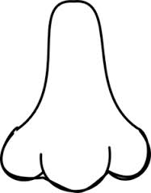

**for tasting**

[](http://www.google.com/imgres?imgurl=http://www.clipartguide.com/_named_clipart_images/0511-1205-1816-2462_picture_of_a_mouth_with_a_tongue_sticking_out_in_black_and_white_in_a_vector_clip_art_illustration_clipart_image.jpg&imgrefurl=http://www.clipartguide.com/_pages/0511-1205-1816-2462.html&h=350&w=310&tbnid=NzS2xhpzSyfRpM:&zoom=1&docid=b8YbZMyEGsCj5M&ei=BwTNU86HLsGkPfahgbgM&tbm=isch&ved=0CGkQMyg2MDY&iact=rc&uact=3&dur=590&page=3&start=37&ndsp=23)

**for walking**

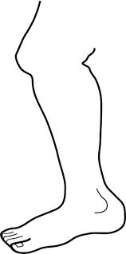 

**for hearing**

4. The name of our head teacher is

___________________________________________________

**(Mr. Mulangila John, Mr. Ssemakula Robbert)**

5. Write the name of your class teacher

___________________________________________________

**6. Name these school symbols.**

|  |  |  |
| --- | --- | --- |
| C:\Users\user\Desktop\FLAG 2.png |  | **Shirt** http://t0.gstatic.com/images?q=tbn:ANd9GcTSUfyB2vYB5RyCY-BG2_FQqdYmjQJV9C415rtPnjv9DROQo4OTsqigkKI |
|  |  |  |

**(school badge, school uniform, school flag)**

**7. Underline the bad behavior**

greeting, fighting, praying

**8. Name two things found on our way to school.**

(i)_______________________ (ii)_______________________

**9. Draw these buildings at school.**

|  |  |
| --- | --- |
| kitchen | classrooms |
|  |  |

10. _______________________________ heads a home

**(Headteacher, Father)**

11. _______________________________ cares for children.

**(Father, Mother)**

13. _________________ is a place where people and animals live. **(School, Home)**

14. ________________________ is a person who lives near you.

**(Father, neighbour)**

15. The colour of the sun is ________________________________

**(yellow, pink, red)**

**16. Draw these people found at home.**

|  |  |  |
| --- | --- | --- |
|  |  |  |
| **mother** | **grandfather** | **sister** |

17. _____________________________ are animals kept at home.

**(Domestic animals, wild animals)**

18. A cow gives us meat and ______________________________

**( pen, milk, pencil )**

**19. Match correctly.**

cow chick

dog kid

goat calf

hen puppy

**20. Draw these things found on our way to school**

|  |  |  |
| --- | --- | --- |
| insects | church | stones |
|  |  |  |

21. Our_______________________ tells us to work hard.

22. __________________________ makes pupils smart.

**(school uniform, school motto)**

**23. Match correctly**

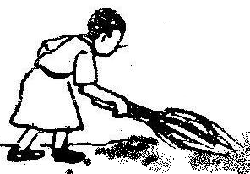

**playing**

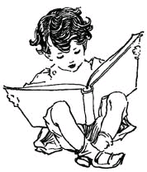

**reading**

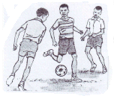

**sweeping**

1. a) Name this animal kept at home.

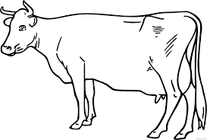___________________________________________________

b) Write any one product got from that animal.

___________________________________________________

c) The above animal lives in a ______________________________

1. **Name these things God created.**

 _________________________________

 _________________________________

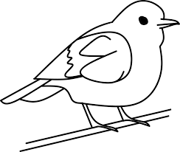 __________________________________

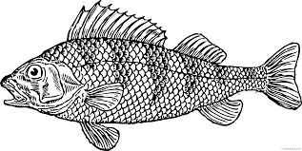 ___________________________________

|  |  |
| --- | --- |
| **Parent`s comment:** | ………………………………………………………… |
| **Signature:** | ………………………………………………………… |
| **Contact:** |  |

**“GOOD LUCK”**